Designing Enterprise Retrieval-Augmented Generation Systems
1. Introduction
Large Language Models (LLMs) generate responses from knowledge learned during training, but they cannot access new or organization-specific information. This limitation often leads to outdated or inaccurate responses.
Retrieval-Augmented Generation (RAG) addresses this problem by retrieving relevant information from external documents before generating an answer. During Week 2, an Enterprise Document Intelligence Platform was developed using Streamlit, LangChain, Sentence Transformers, and ChromaDB. The application allows users to upload enterprise documents, convert them into embeddings, store them in a vector database, and perform semantic question answering.
2. Enterprise RAG Architecture
The developed system follows a modular Retrieval-Augmented Generation architecture. Documents uploaded by the user are processed, split into smaller chunks, converted into embeddings, and stored inside ChromaDB. When a user asks a question, the system retrieves the most relevant document chunks and sends them together with the query to the language model, which generates the final response.
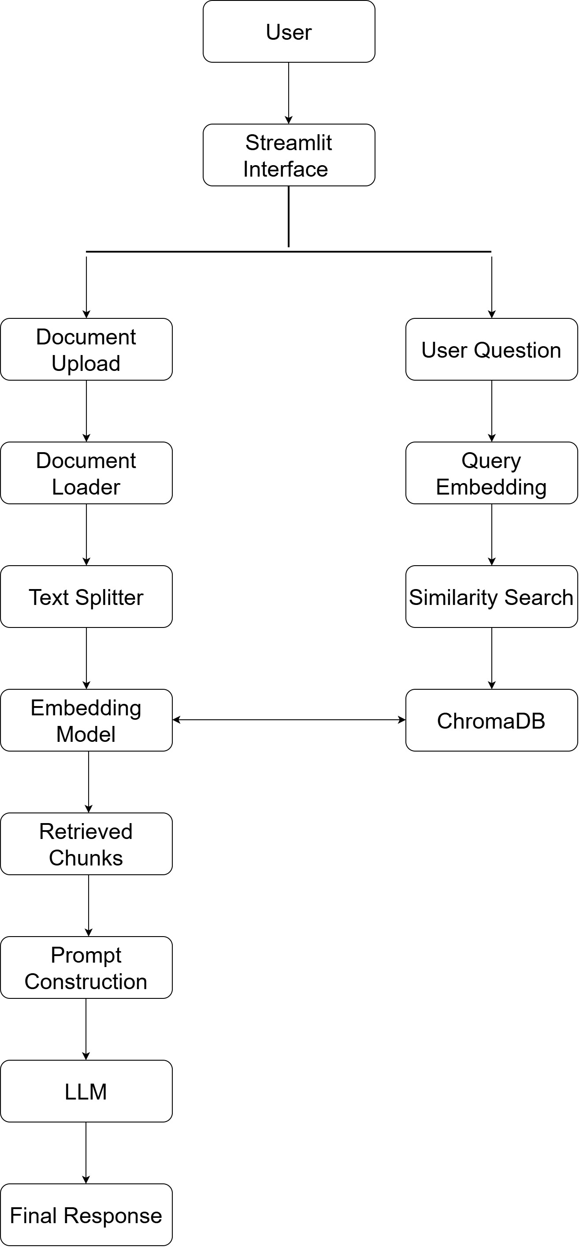
Figure 1: Enterprise RAG Architecture
3. Embeddings
Embeddings convert text into numerical vectors that capture semantic meaning. In the project, the all-MiniLM-L6-v2 Sentence Transformer model was used to generate embeddings for every document chunk. These vectors were stored in ChromaDB, enabling semantic search instead of simple keyword matching. When a user asks a question, the query is also converted into an embedding so that similar document chunks can be retrieved efficiently.
4. Chunking
Enterprise documents are often too large for a language model to process directly. Therefore, documents were divided into smaller chunks using RecursiveCharacterTextSplitter.
The project used:
- Chunk Size: 800 characters
- Chunk Overlap: 150 characters
Chunk overlap preserves context between adjacent chunks, improving retrieval quality while keeping the chunks small enough for efficient embedding generation.
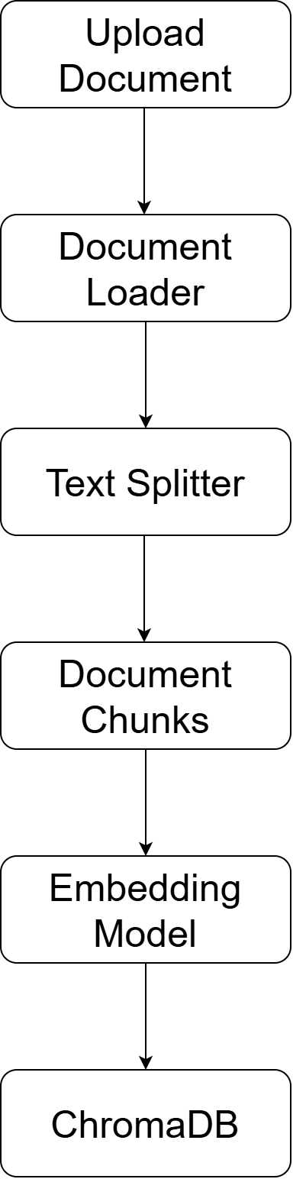
Figure 2: Document Processing Pipeline
5. Retrieval
When a user submits a question, the application converts the question into an embedding and performs semantic similarity search in ChromaDB. The most relevant document chunks are retrieved and used as context for answer generation. Unlike keyword search, semantic retrieval identifies information based on meaning, resulting in more accurate responses.
6. Prompt Construction
Prompt construction combines the retrieved document context with the user's question before sending it to the language model. This ensures that the generated response is based on the uploaded enterprise documents rather than relying only on the model's pretrained knowledge.
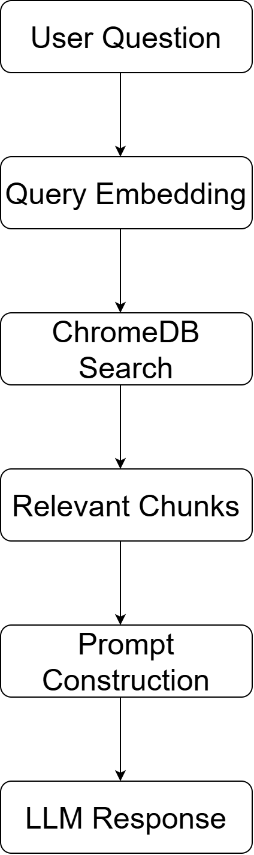
Figure 3: Retrieval Pipeline
7. Vector Databases
A vector database stores embedding vectors and performs similarity search. In this project, ChromaDB was selected because it integrates well with LangChain, supports persistent storage, and provides efficient semantic retrieval. Compared with traditional databases, vector databases are better suited for handling embedding-based searches.
8. Hallucination Reduction
Hallucinations occur when a language model generates incorrect or unsupported information. The developed RAG system reduces hallucinations by retrieving relevant document chunks before generating responses. Since the model receives factual document context, answers become more reliable and grounded in the uploaded data.
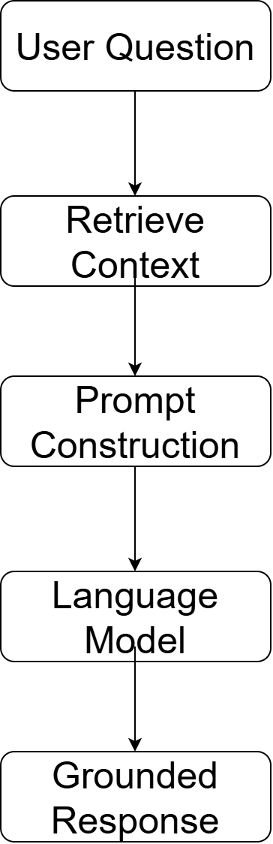
Figure 4: Hallucination Reduction

9. Future Improvements
The Enterprise Document Intelligence Platform can be enhanced by:
- Supporting additional document formats.
- Implementing hybrid keyword and semantic search.
- Deploying the application on cloud platforms.
- Adding response citations for retrieved sources.
- Implementing user authentication and access control.

